3G150B-How to setup the Router Mode?
Product line: 3G Question category: Internet settings

Note: 3G150B has three working modes: AP mode, Wireless Router mode, 3G Router mode. The default working mode of 3G150B is AP mode, while if you insert a 3G modem to the 3G150B, it will transfer to 3G Router mode automatically. The default LAN IP address of 3G150B is 192.168.2.1.Under the Wireless Router Mode, we can login to the homepage of 3G150B only by wireless signal.

The topology should be as below：
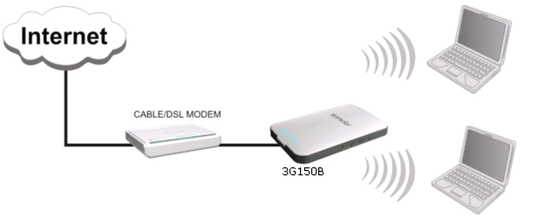
The Steps are as below:
I: change to wireless router mode
1．Connect your computer to the LAN/WAN port of 3G150B by an Ethernet cable. And then change the IP address of your computer to 192.168.2.X (X can be 2--254) manually.
2．Login the homepage of the 3G150B by inputting http://192.168.2.1 in the address bar of your web browser. The default Password is “admin”
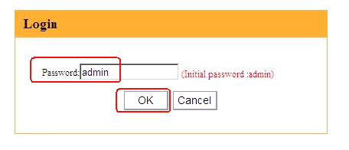
3．In the initial setting page of 3G150B, please click “Advanced Settings”, then you can login to the homepage of the 3G150B.
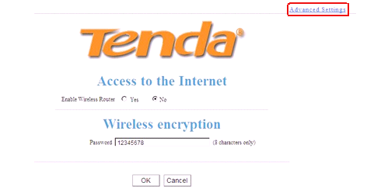
4．Click on Wireless settings->basic settings, you can see the picture as below. Please choose 11b/g/n mixed mode, change the SSID to tenda123 (the name of wireless network) and choose channel 6, then click OK to save the settings.

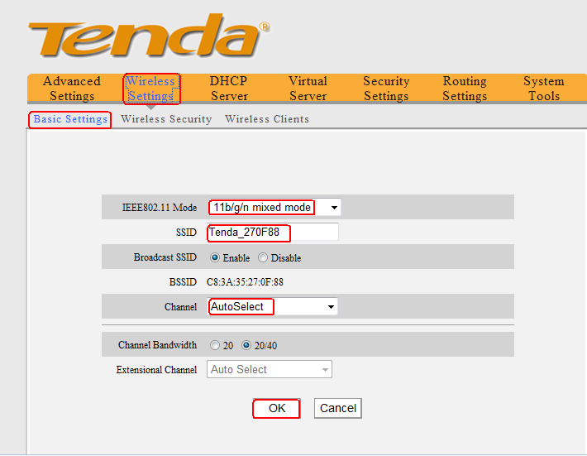

5．In the homepage of 3G150B, please click Enable Router, and tick Enable Wireless Router, then click OK. The router will reboot automatically.
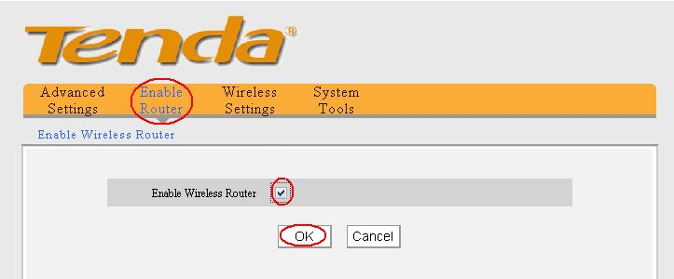
6．Now we can remove the Ethernet cable between your computer and the 3G150B. We can login to the homepage of the 3G150B wirelessly. Please connect to the wireless signal of 3G150B on your laptop.
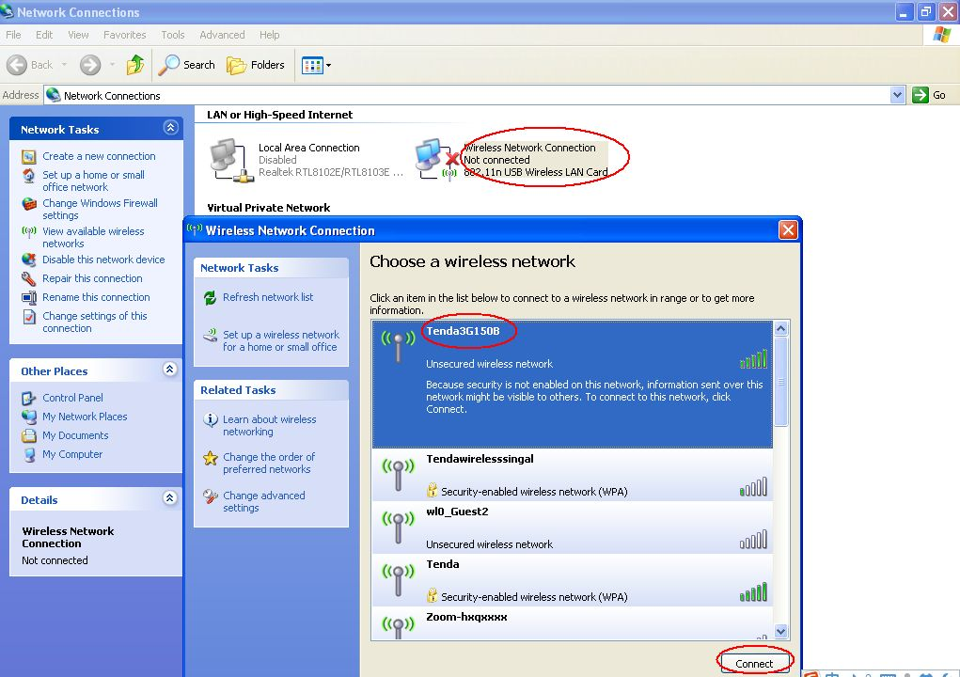
II: setup the wireless router
1. Please login to the homepage of the 3G150B again by input http://192.168.2.1 in the address bar of your web browser. The default Password is “admin”.
2. Click Advanced Settings→WAN settings, in the drop down menu of Mode, please choose the internet connection type of yours (if you don’t know which one you should choose, please consult Cable Company) as the picture below. And click Ok to save the settings.
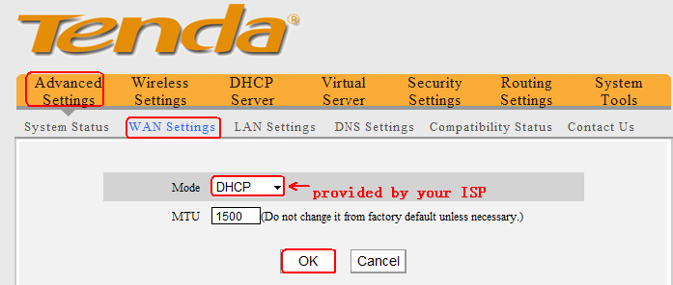
3. Click on Wireless settings->wireless security, you can see the following page.
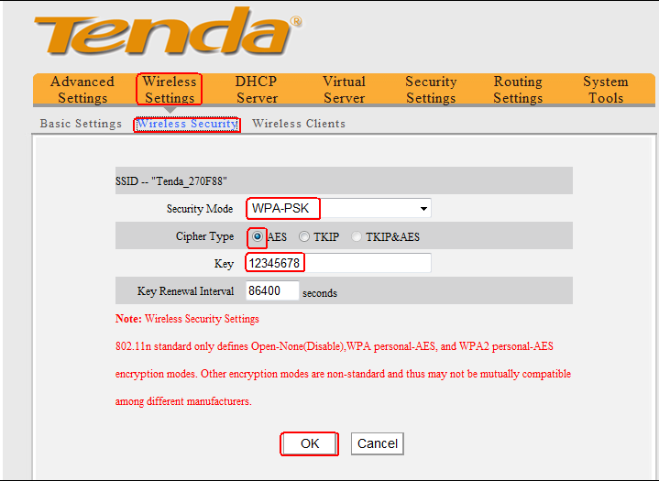
Security Mode: choose WPA-PSK
Cipher Type: choose AES
Key: set it by yourself (it is the password of your wireless network)
Then click OK to apply
4. The settings for the Wireless Router mode of 3G150B are done. You can use your computers to connect to the wireless signal of 3G150B.
II, connect computers to Internet wirelessly
Please find the name of your wireless network (it is SSID tenda123) and connect to it. It will require you to input password, please type password (It is the key which was made by yourself just now.) After that, you can enjoy the internet wirelessly.

